**Data Never Sleeps**- 80 % of enterprise data is Unstructured

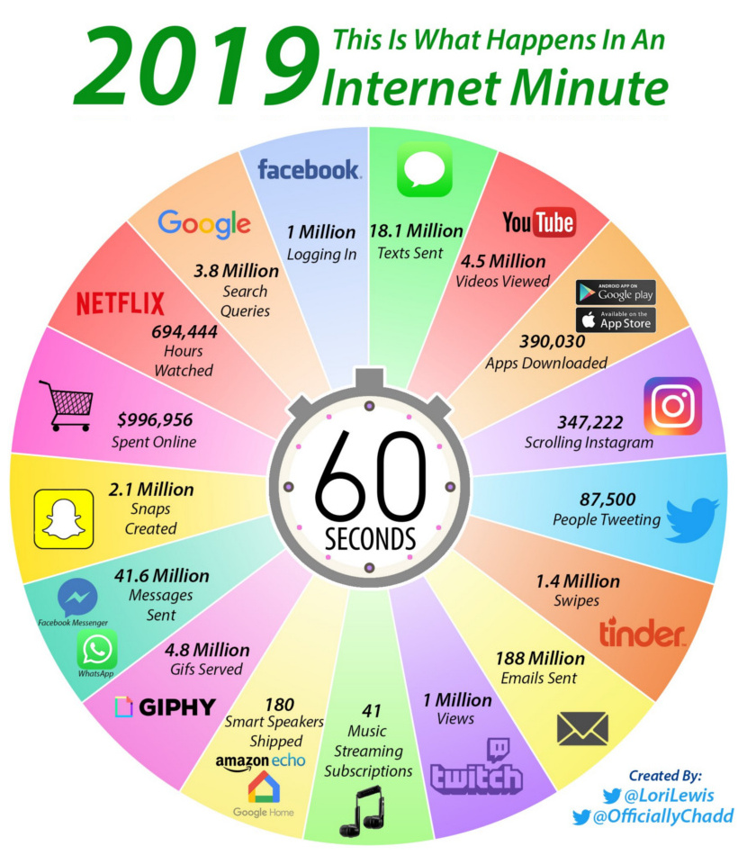

**NLP Challenges**

**Stanford University -Winograd Schema Challenge**

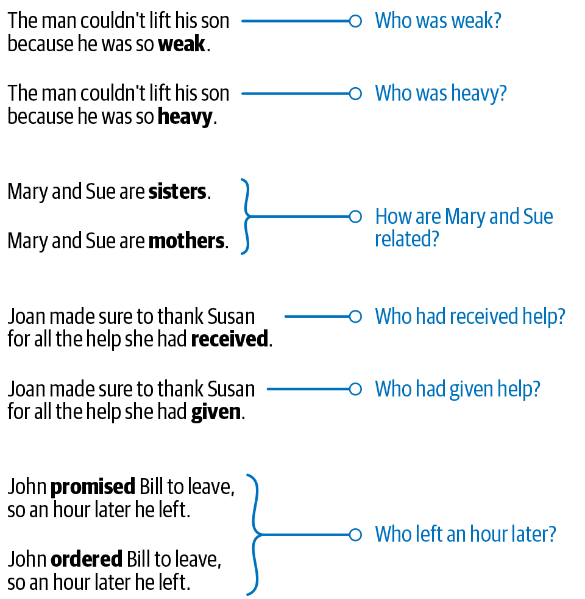

**Common Knowledge in Human**

man bit dog

dog bit man

**DIVERSITY ACROSS LANGUAGES**

* *Yaar tu to*, GOD *hain*. **tui**
* JU te ki korchis? Hail u man!

**Ambiguity in the Meaning**

